**With United Ryukyu Kempo Alliance Founder, Amor Kaicho September 8 & 9th.**

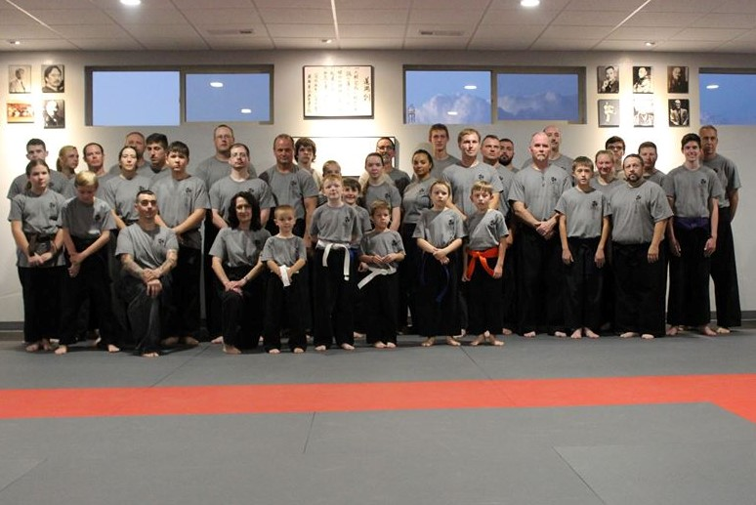

**West Texas Karate**

**307 Country Club Dr.**

## Canyon, TX 79015

**806-382-5503**

[**www.bushukan.com**](http://www.bushukan.com)



**2017 Texas Seminar 9/8-9/9**

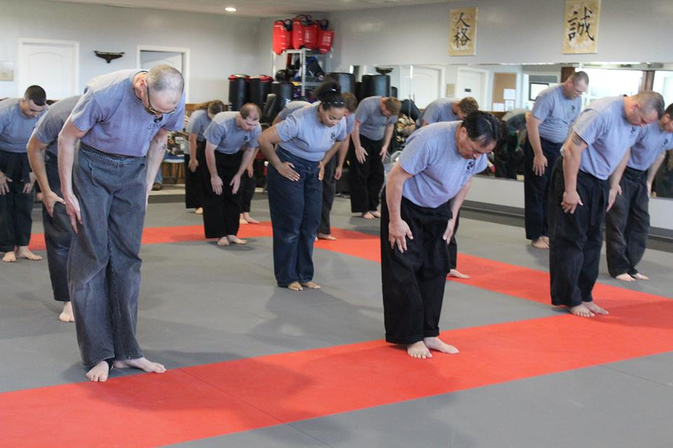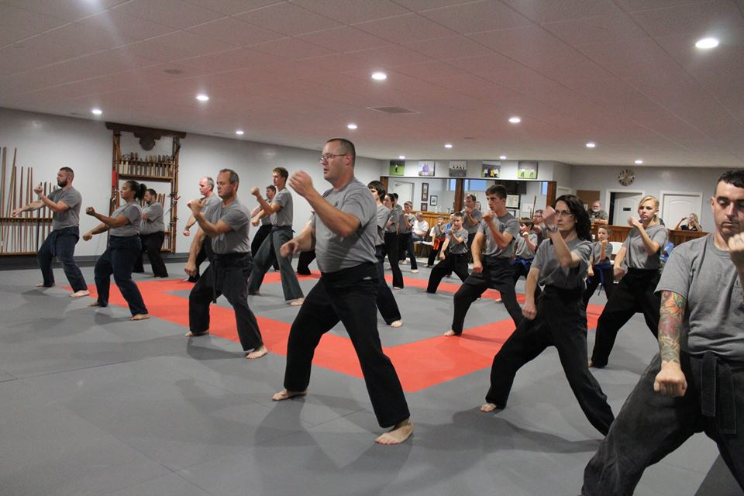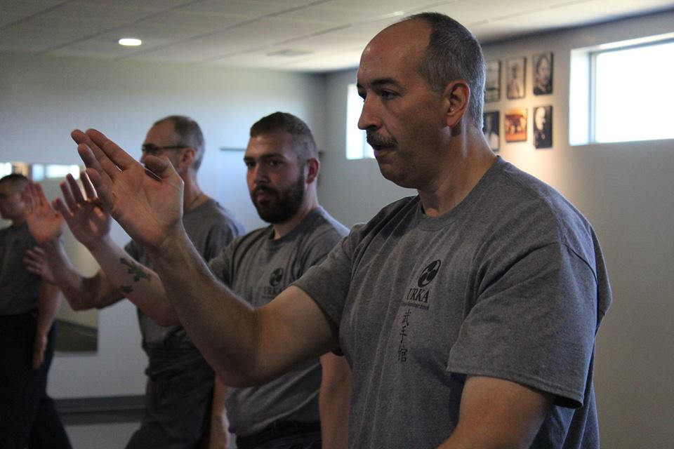

**Seminar Includes:**

**-Training Friday – Saturday – (Comparable to over 2 months of class!)**

**- Lunch provided Saturday**

**-Custom Seminar T-Shirt**

**-Catered BBQ Dinner Saturday Evening\***

**\*Family members welcome - $15 each**

**Tuition:**

* **$125 per participant**
* **Sr. Yudansha $95 (with understanding that you may be asked to assist with some teaching)**
* **$75 each additional family member**
* **Students 8 and under $50**

**Registration deadline: August 21,2017 (Registrations received after deadline may not**

**receive a seminar T-shirt)**

For information contact:

## Renshi Guyle Corley

**West Texas Karate**

**307 Country Club Dr.**

## Canyon, TX 79015

**806-382-5503**

[**www.bushukan.com**](http://www.bushukan.com)

# 2017 Texas Seminar Schedule

**Friday: Training 8-5 pm & 6-8 pm**

**Saturday: Training 8:30 – 5:00 pm**

**6:00 – BBQ Dinner**

**Special rate, times & classes for students 8 and under:**

#### Friday: 6-8 pm

**Saturday 10-12 noon & 3-5 pm**

**Training will include open hand kata/exercises\***

**Tuite & Kobudo\*\***

**\*\*The dojo is limited on the availability of weapons for training. We are asking students to please bring their own weapon if possible.**

